SPARK: Simple Play Adaptations to Reference for Kids

Toloso 4G Kids Watch with GPS Tracker
Description: | Image:
The smart watch is 3.35 x 2.36 x 3.35 inches and weighs 1.13 ounces; 1 Lithium Polymer batteries required. (included). It is designed to ensure the safety of kids aged 3-12. NOTE: It operates on cellular data. Special Features include GPS, SOS Button, Phone Call, Voice & Video Chat, Activity Tracker, Camera, Pedometer, Alarm Clock, and Touchscreen. With a long press of the SOS button, it instantly triggers emergency rescue, supporting 4G voice and video calls, as well as voice chatting. | 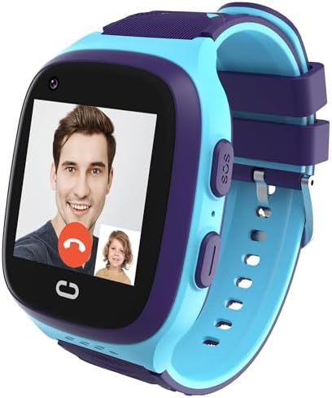

Who Might Benefit?
Those who…
• Are responsible for supervising children.
• Act on impulse and try to leave the area.
• Attempt to follow another individual leaving the area.
• Will be able to understand multiple functions of a watch.

Why Use?
Provides an opportunity to…
• Acts as a safety measure for those who try to leave an area due to:
• Becoming overstimulated in the classroom, at home, or in the community
• Wandering from supervised areas
• Being frightened or upset
• Attention Seeking
Instructions for Use: | Adaptation Ideas:
Environmental Considerations  - Be aware of how the noise level or amount of visual stimulation or busy activities may affect certain children.  - Create boundaries such as a taped box in front of the doorway as a “no stand zone”.  - Place the desk or table where the teacher spends the most class time close to the door to allow for quick intervention.  - Place a stop sign on door or outside gate.  Positioning  - Place the child away from an accessible door. If possible, have an adult positioned close to the child as well as the door to redirect them if they try to leave.  - Position the watch on the child’s wrist and fasten so that it cannot easily slide off.  Basic Play/Use  - Fully charge the device before first use  - Press the power button for 6 seconds to power on.  Play/Use with Others  - Create a poster about leaving the area to be reviewed daily in morning circle/meeting, as well as posted on or near the door as a reminder to children who struggle with elopement.  - Combine poster or social stories about leaving designated areas with community signs/traffic lights with concepts of stop (red light), go (green light), wait or caution (yellow light).  - Play Red Light Green Light game and discuss instances of when it is important to stop, and OK to go.  - Child should be shown how to use the watch and coached about when to use it. | Communication Support  Visuals displaying options of things children can say or do when they feel like they need to "get away".  - Create lanyards for all staff with visuals including stop, wait, I need a break.  - Create an individual or class Social Story (e.g., Staying with My Class, Running Away, I Can Choose to Be Safe)  DIY Alternatives  - “Sleigh bells” or other movement triggered noise maker on doors and gates.  - Stop signs posted on doors and gates.

Additional Considerations:

Child should have fine motor skills required to use watch face touch screen.

Resources:
- See Social Narratives from OCALI’s Autism Center Grab and Go Resource Gallery of Interventions.
- For further information, visit the Social Narratives Autism Internet Module.
- Like Social Stories, Power Cards teach and reinforce academic, behavioral, organizational, and social skills. Power Cards are visual supports that include an individual’s special interest. See Power Cards from OCALI’s Autism Center Grab and Go Resource Gallery of Interventions.
- Reminder Cue Cards from OCALI’s Autism Center Grab and Go Resource Gallery of Interventions help teach and remind individuals how to engage in positive behaviors. Reminder Cue Cards provide “what to do” suggestions when an individual is feeling anxious, stressed, or confused. They also support interactions with peers, and offer ways to self-regulate, and manage emotions.

Ohio Early Learning Standards:

SS. People, Communities, and their Environment: Develops understanding that everyone has rights and responsibilities within a group (1.c.).
- PD&W. Wellness: Demonstrates increasing understanding of safety practices and behaviors (2.f.).

Words to Encourage Play/Use
Stop | Go | Wait
Open | Close | Help
Sad | Mad | Scared
*”Adaptations” adapted from: Haugen’s Modes for Adapting Toys based on materials from the "Let's Play" Project at the University of Buffalo
PCS is a trademark of Tobii Dynavox, LLC. All rights reserved. Used with permission.

